COVID-19 TENTS NETWORK PLAN

SYDNEY RUDNY

MILLIKIN UNIVERSITY

Contents

Logical Network Design……………………………………………………………………………………………………………3

Physical Network Design………………………………………………………………………………………………………….4

Treatment Tent…………………………………………………………………………………………………………..5

IT Tent/Triage/Drive-Up………………………………………………………………………………………………6

IP Scheme………………………………………………………………………………………………………………………………..7

Equipment Cost Breakdown…………………………………………………………………………………………………….8

Questions………………………………………………………………………………………………………………………………..11

Work Cited……………………………………………………………………………………………………………………………12

**Logical Network Design**

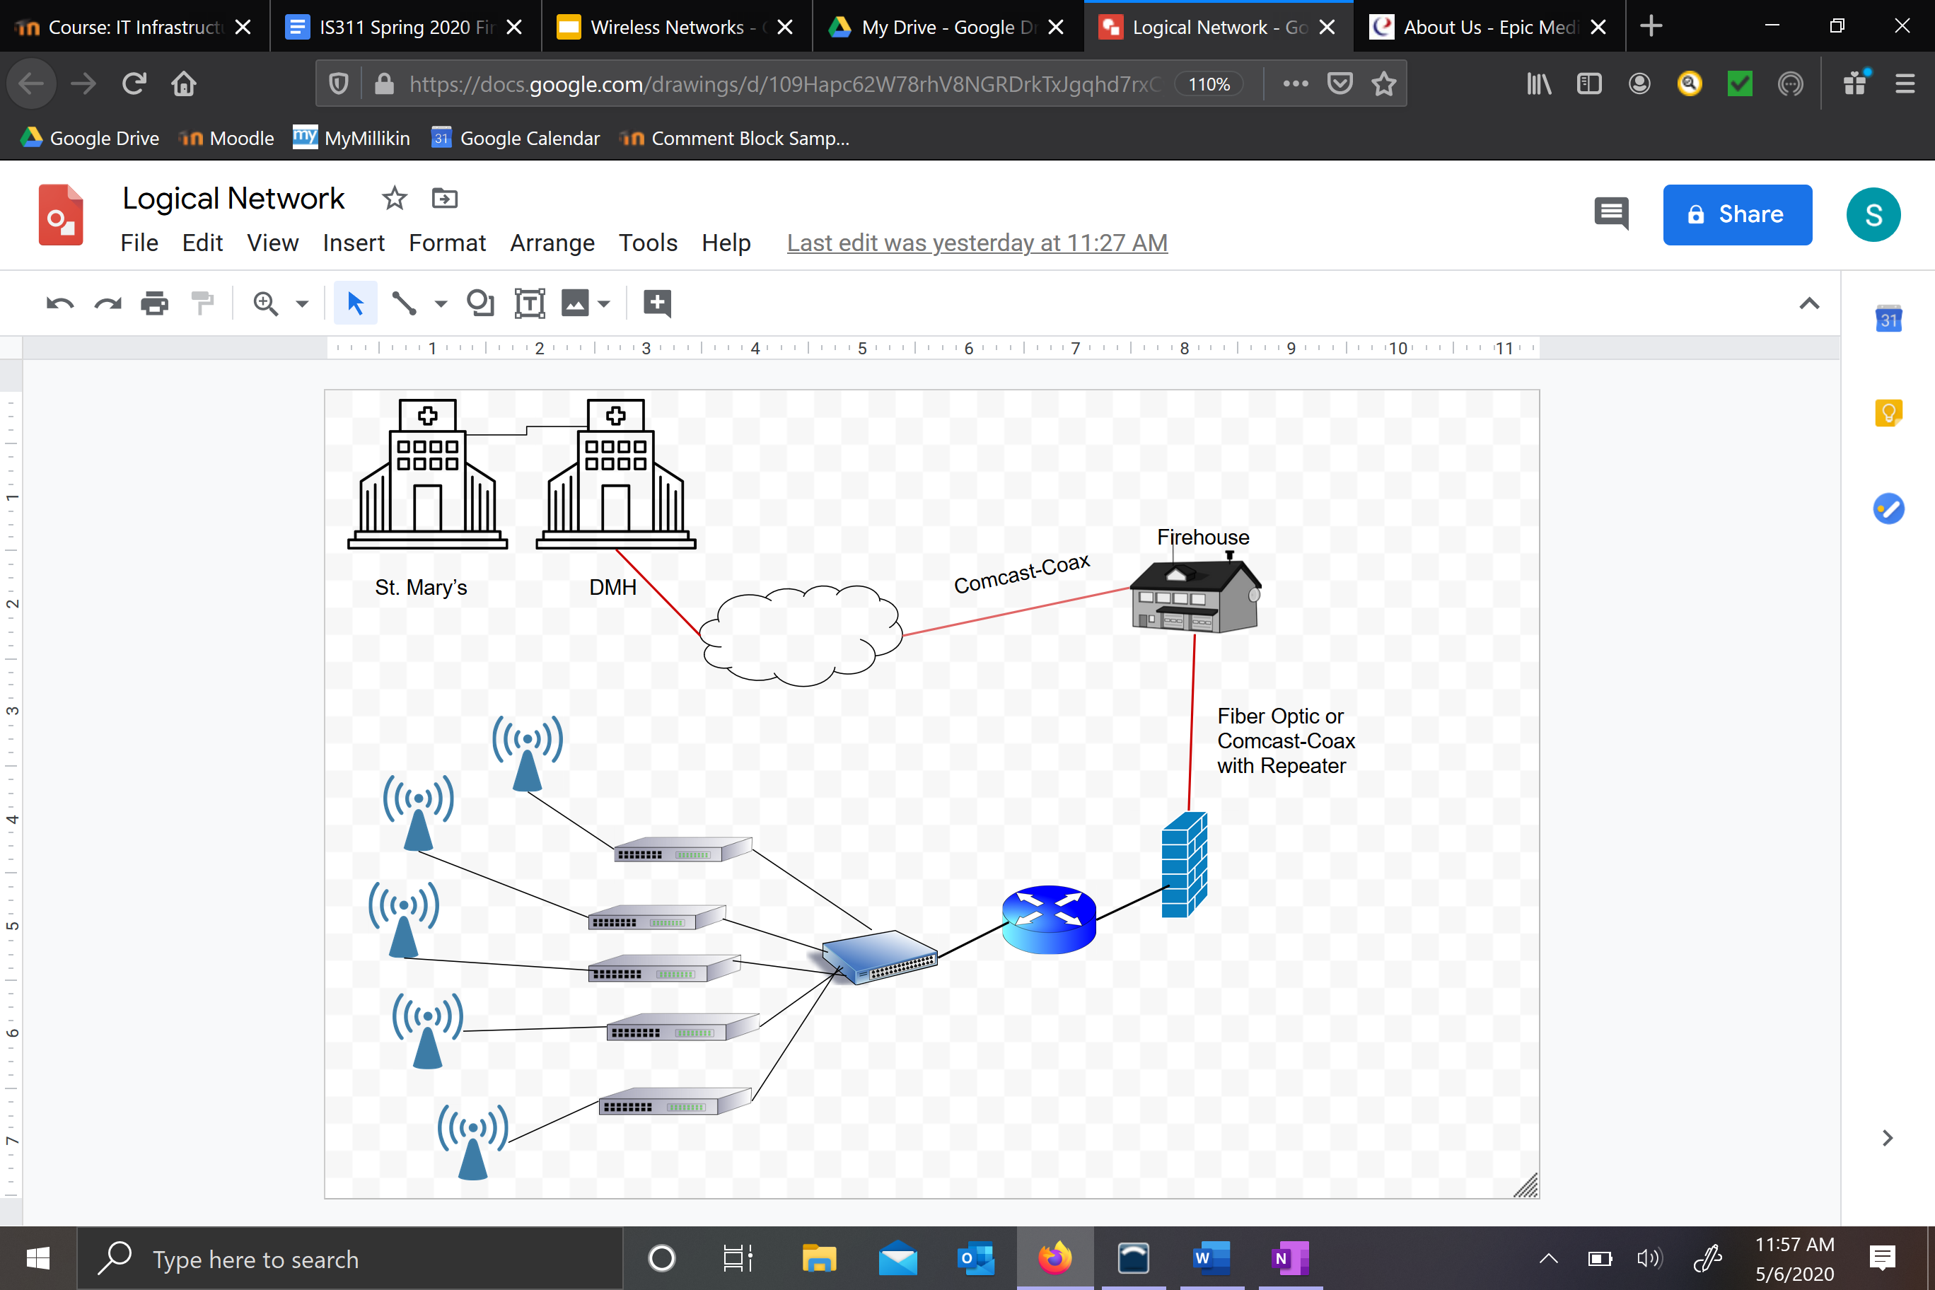

(About Us, n.d.)**Physical Network Design**

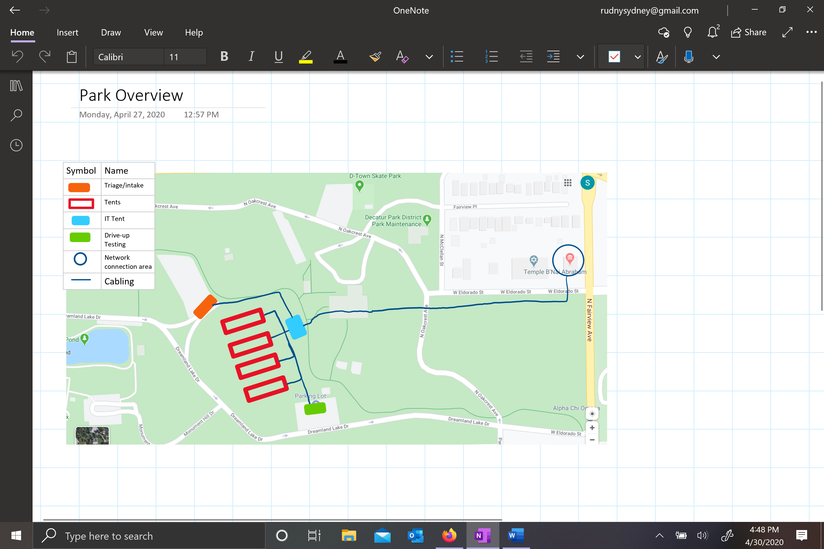

**Treatment Tents (4)**

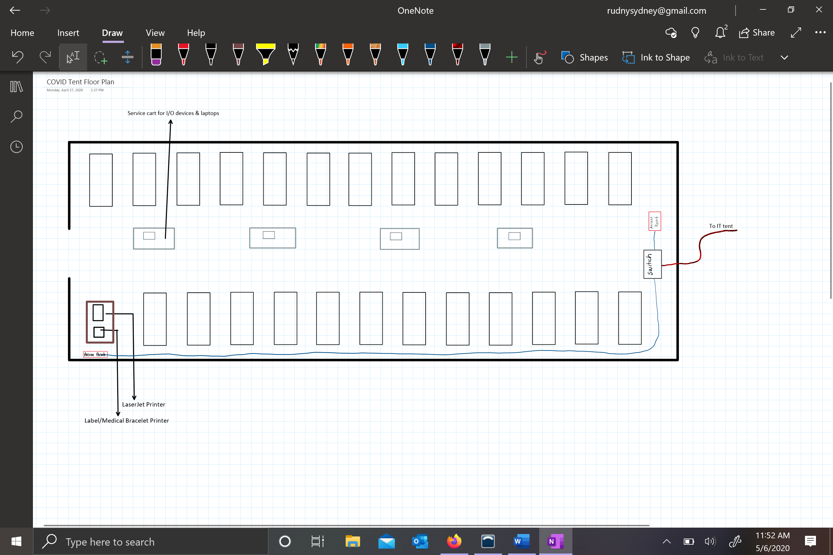

**IT Tent**

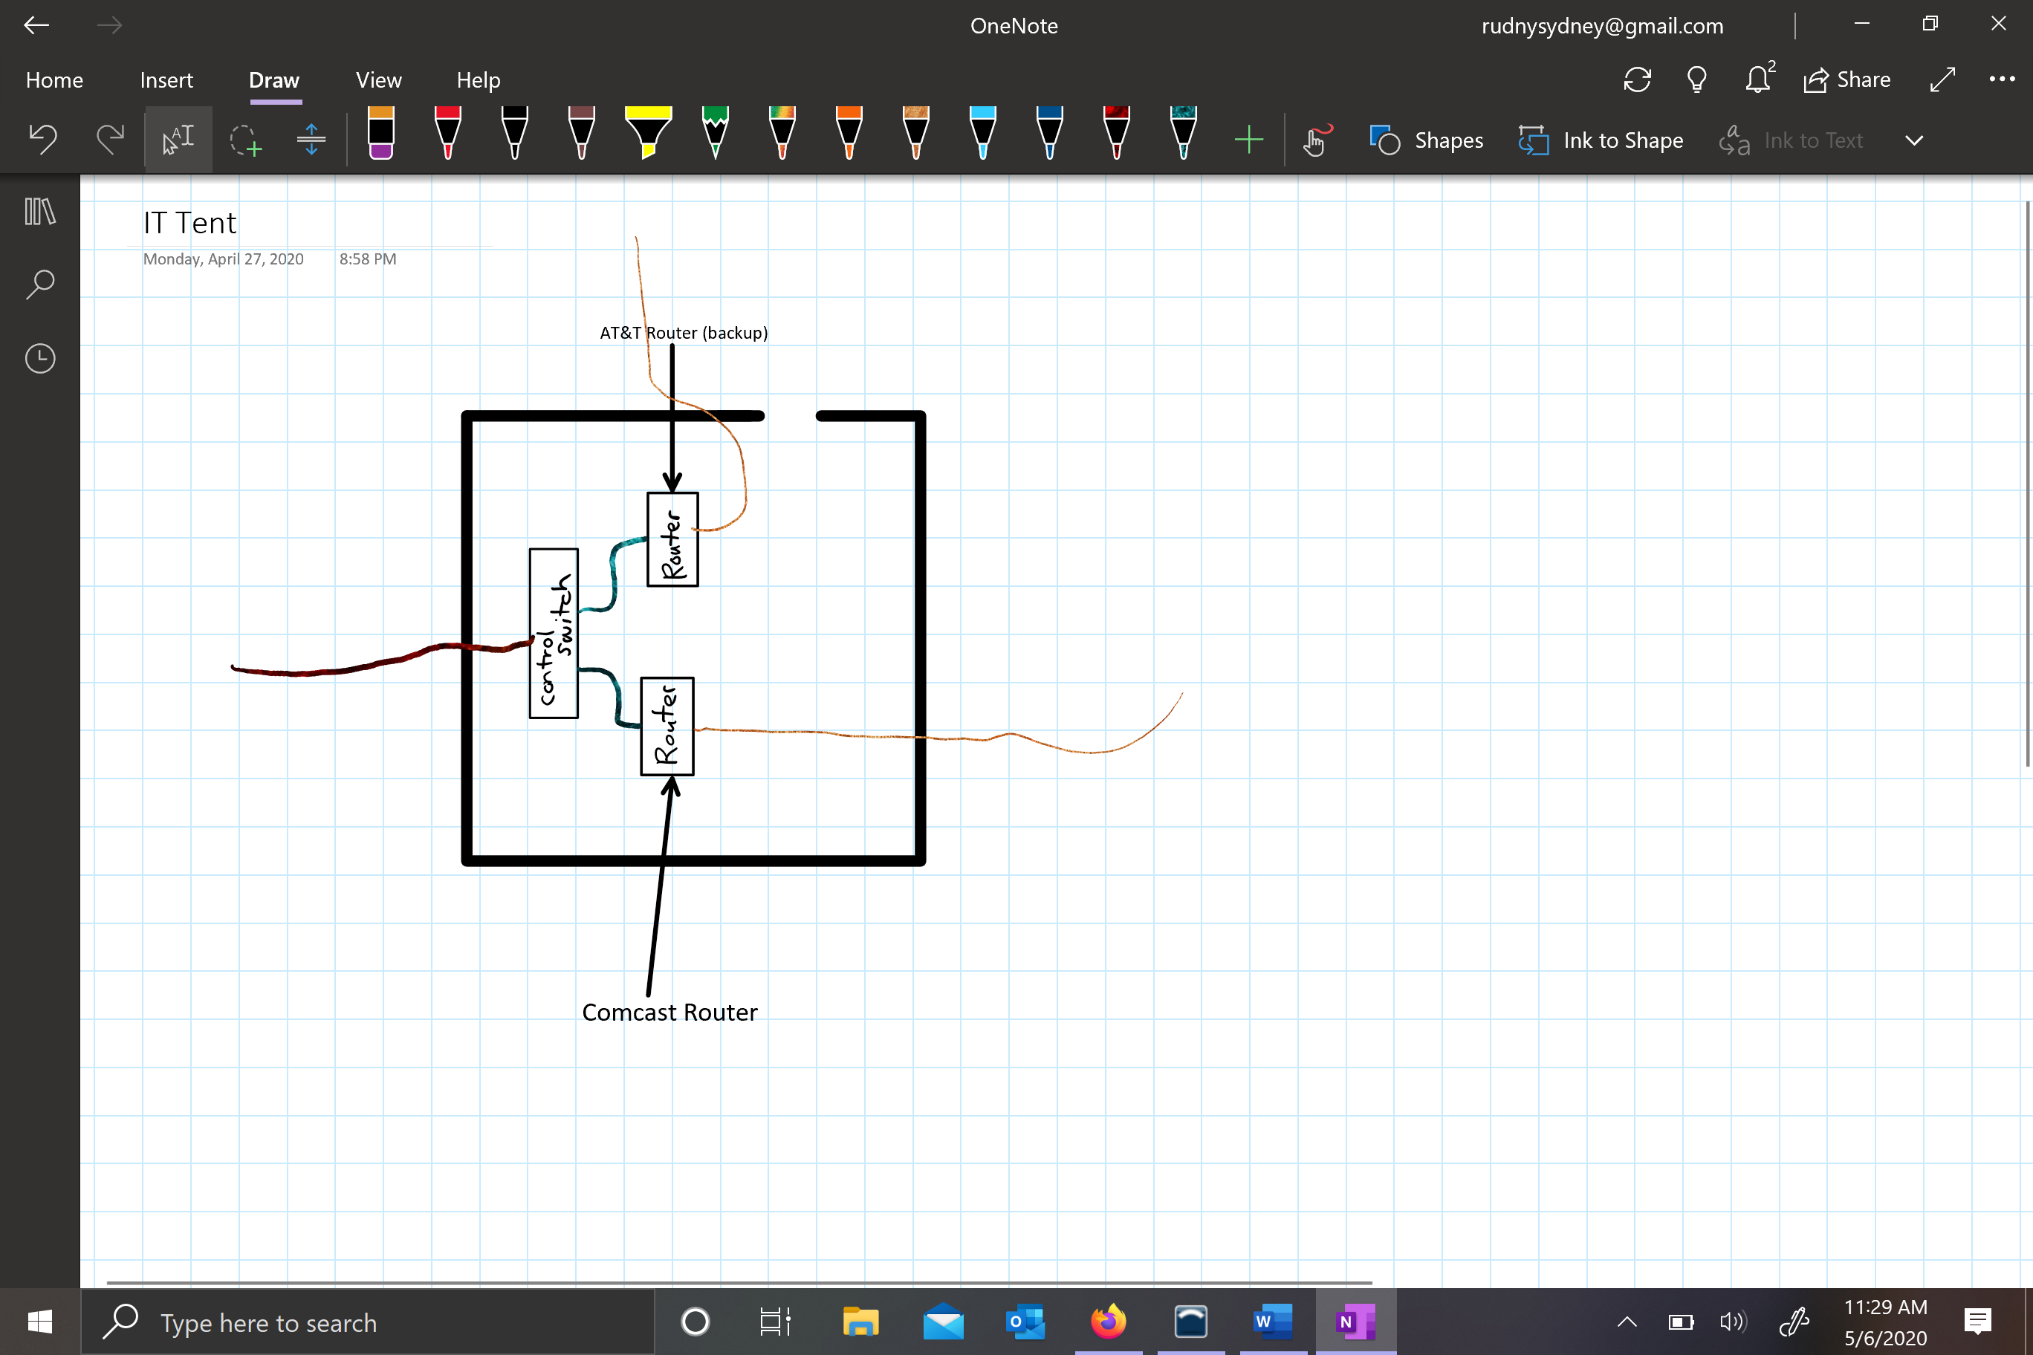

**Drive-up Testing/Triage/Intake**

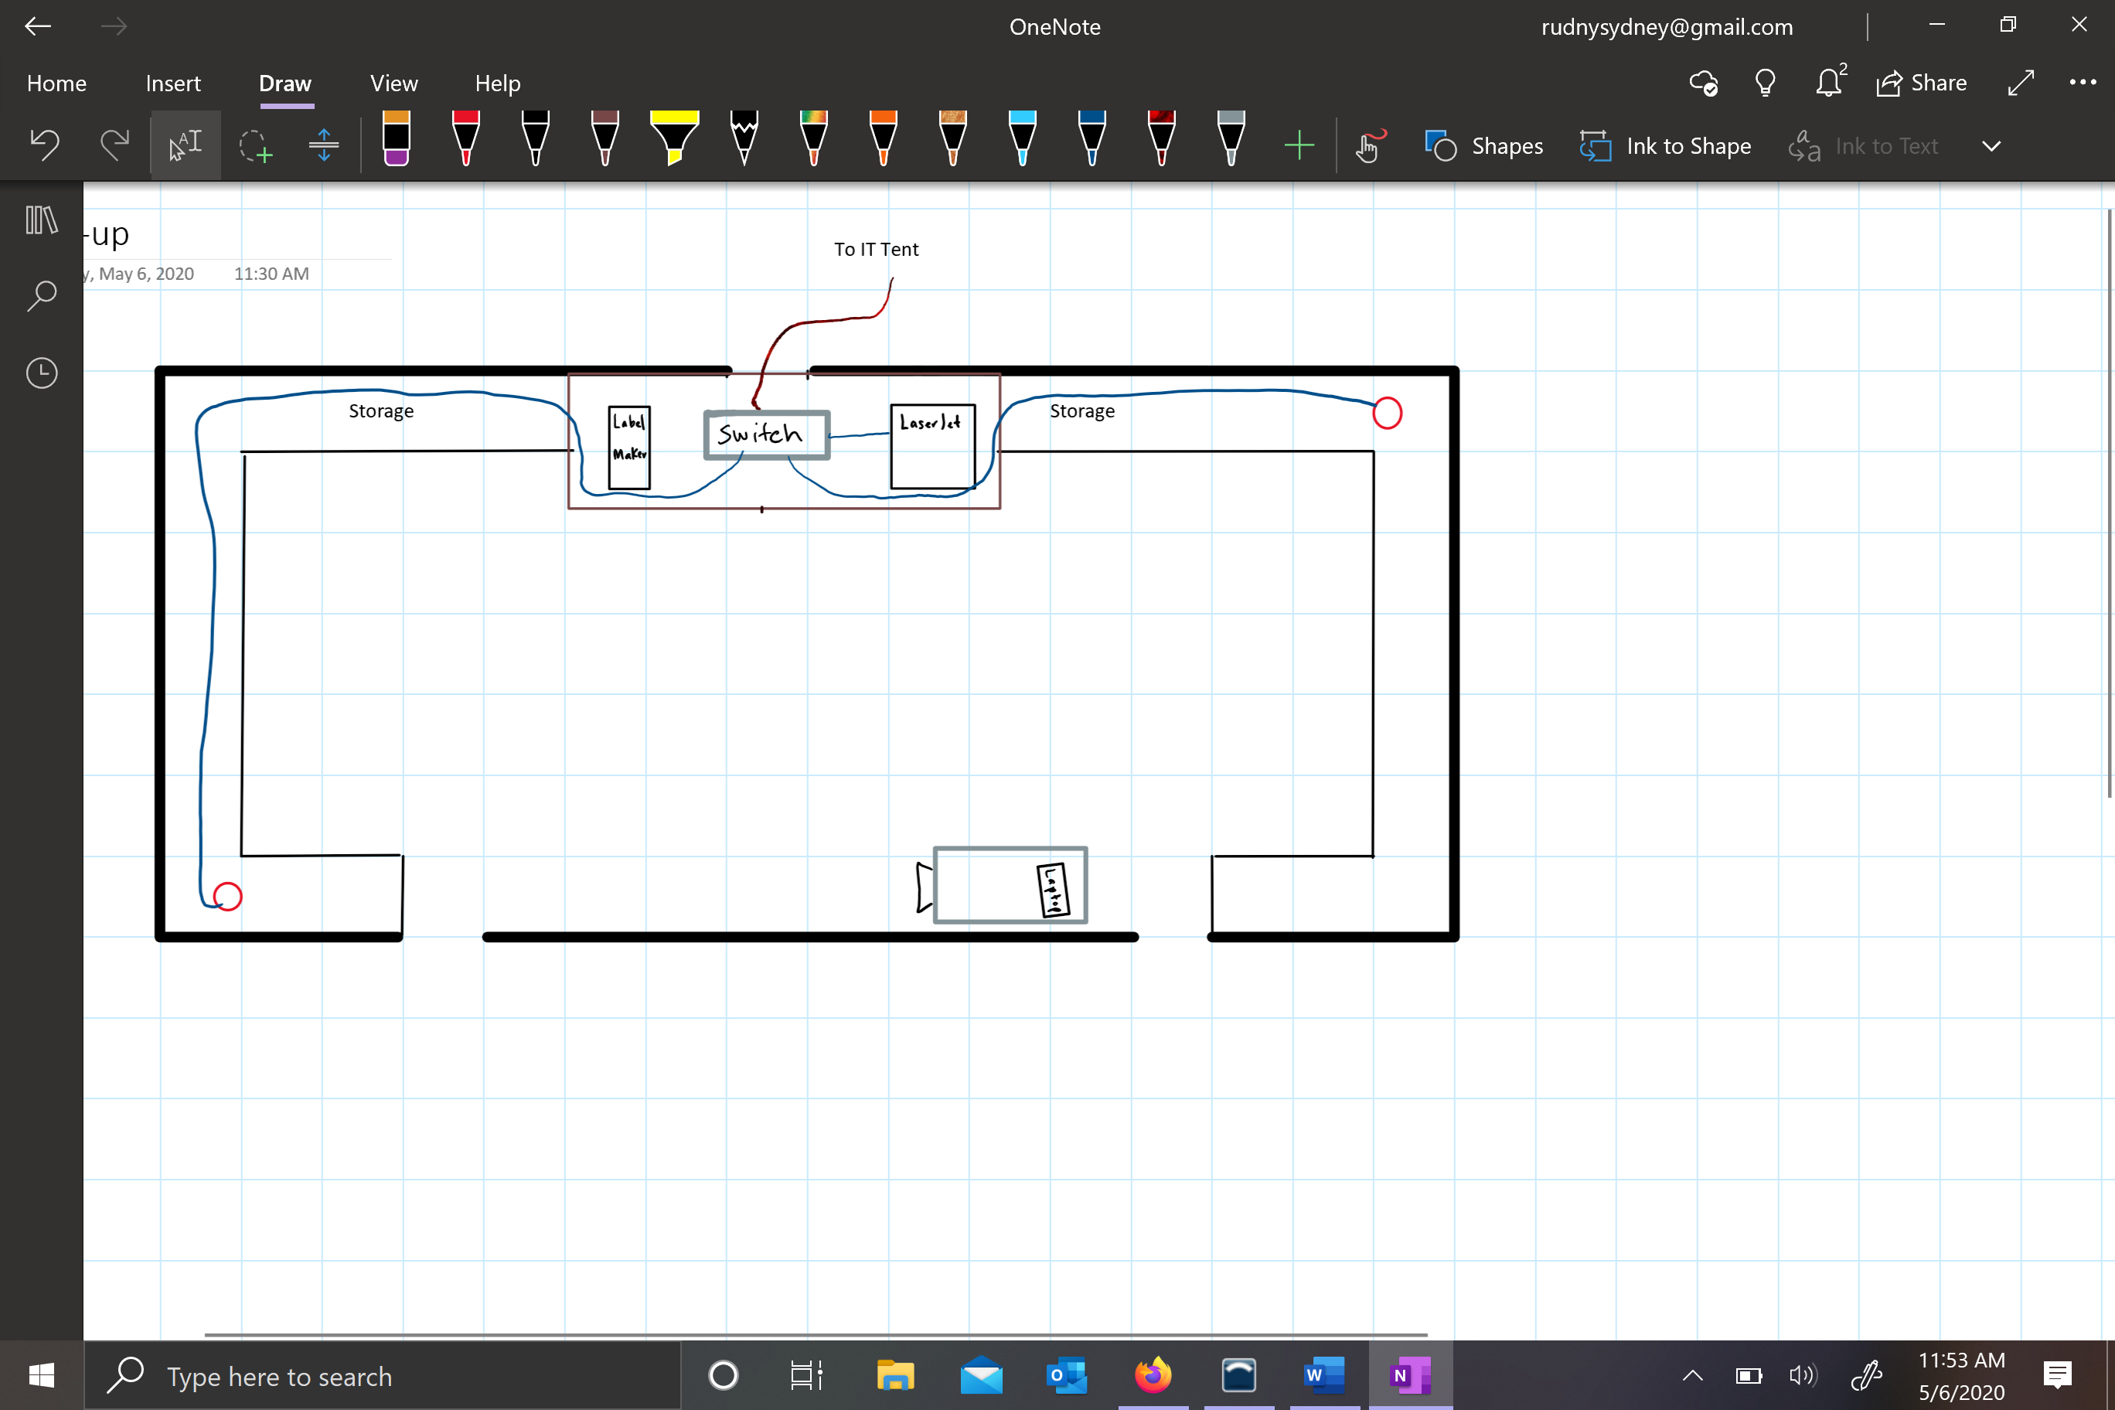

**IP Scheme**

**Pricing**









**Questions/Planning**

**Work Cited**

*About Us*. (n.d.). Retrieved from Epic Medical Solutions: https://epicmedicalsolutions.com/about-us/

Gad, L., Nehemia, B., Yitshak, K., Nachman, A., & Ofer, M. (2010). Application of information technology within a field hospital deployment following the January 2010 Haiti earthquake disaster. *Journal of American Medical Informatics Association*. Retrieved from https://www.ncbi.nlm.nih.gov/pmc/articles/PMC3000757/